Objectives:

* Task 1: Implement Management Groups
* Task 2: Create custom RBAC roles
* Task 3: Assign RBAC roles

Architecture diagram:

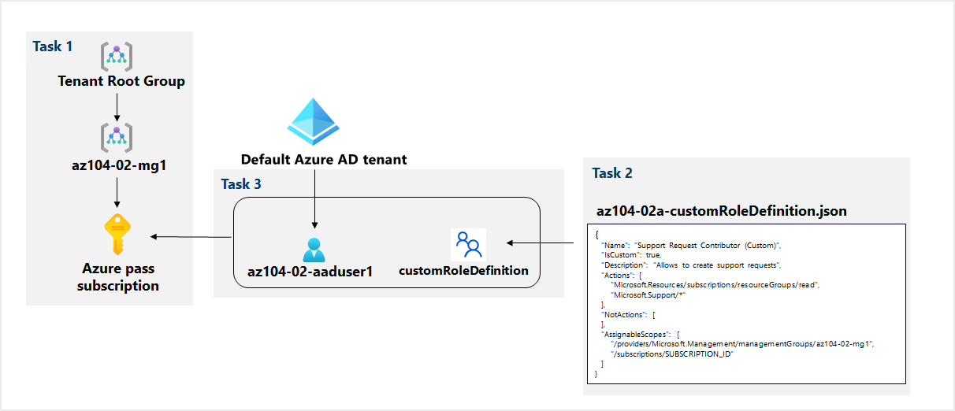

Task 1: Implement Management Groups.

In this task, we will create and configure management group and assign a subscription to it:

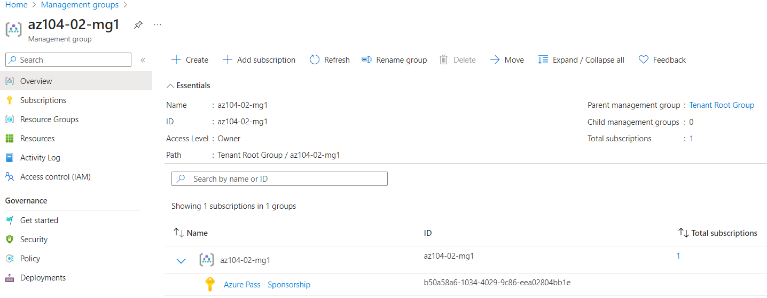

Task 2: Create custom RBAC roles.

In this task, you will create a definition of a custom RBAC role:

First, we have to edit the said JSON file and replace the subscription id with the id we have copied earlier.

Then we open up a Cloud Shell, upload the edited JSON file and run the following command to create a custom role definition:

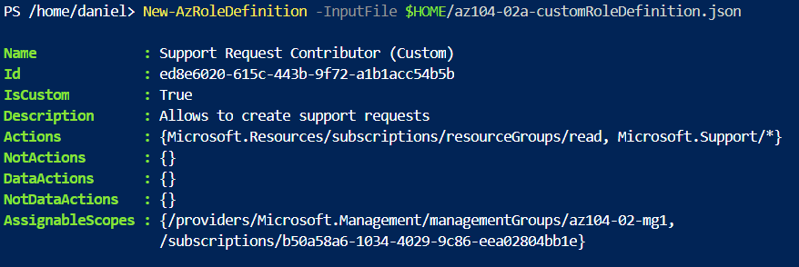

Task 3: Assign RBAC roles.

In this task, we will create an Azure Active Directory user, assign the RBAC role we have created in the previous task to that user, and verify that the user can perform the task specified in the RBAC role definition:

We start by creating a new user as specified and assign the required role:

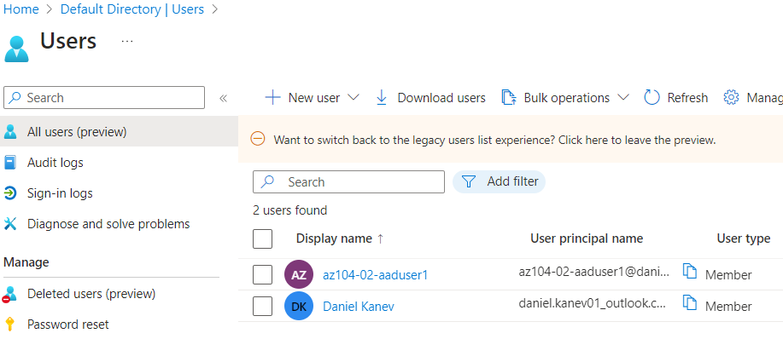

Next, we open up an incognito window, sign in with this newly created user and verify that the user can see all resource groups:

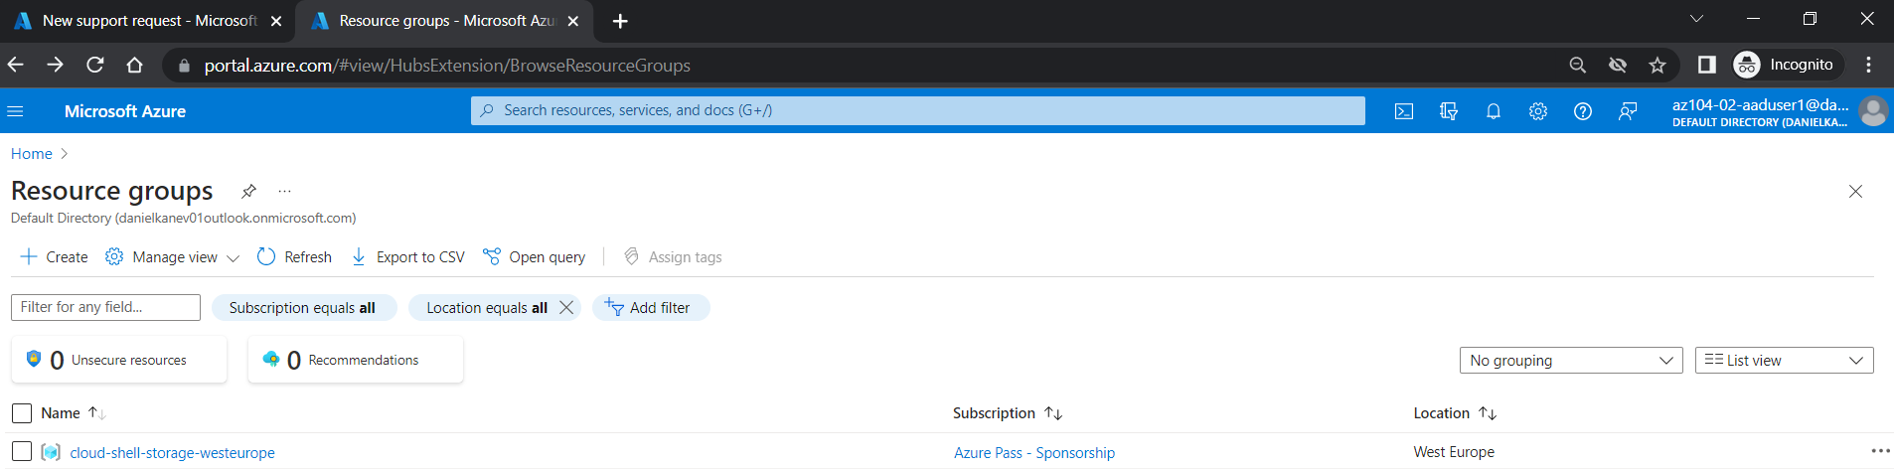

And that he cannot see any resources:

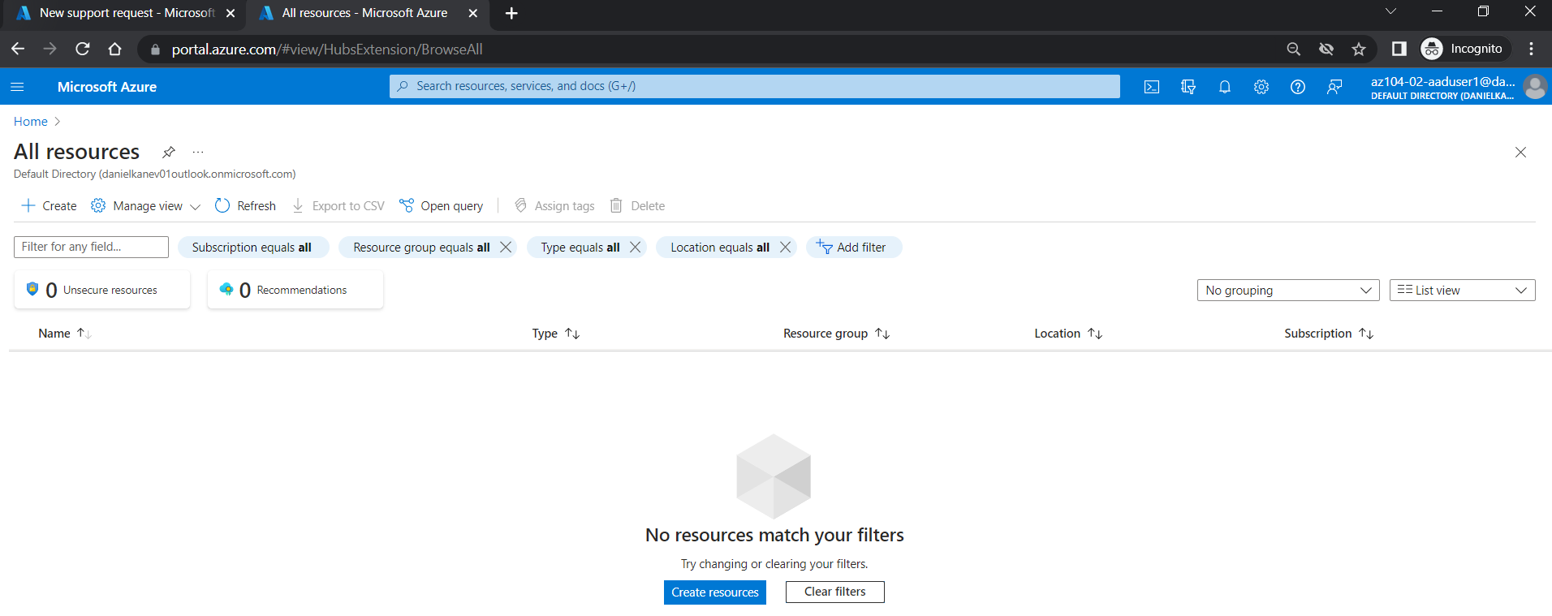

Lastly, we go to create a support request and can see that the correct subscription is selected:

